ELCT 201 – EE Laboratory 6

Laboratory 6, Divide and Conquer

Jacob Vaught
10-30-2022

Department of Electrical Engineering
University of South Carolina
Columbia, SC 29208

Introduction
This lab is an introduction into the basics of troubleshooting via utilizing a divide and conquer method. The lab is a collection of all previous labs conducted and combines them to create an electronic motor control system. The circuit is broken down into 5 main sections, and this plays into the “divide and conquer” aspect. The circuit then has a few random errors introduced by the TAs, then the student is tasked with determining the error and remedying it. A troubleshooting diagram is also created by the student and must be annotated when remedying the artificially introduced errors.
The system has the following functionality objectives:
- Turn Motor on if button is pressed, or if light reaches a threshold higher than ambient lighting
- Turn motor off if stop switch is pressed, motor overheats, or if torque in motor reaches a predetermined stopping point.
- The light sensor, heat sensor, and torque sensor limits should be user modifiable.

Circuit Operation
The Circuit is split into 5 sections, and the sections are as follows:
- User Inputs
- Sensor Inputs
- Sensitivity Calibration
- Logic
- Power output
Overview of the circuit: The circuit is a simple motor control system which illustrates the student’s mastery of complex circuits with multiple digital and analog inputs. It also illustrates the students use of logic gates and op-amps in addition to PMOS and transistors. The circuit should only turn on when light is brighter than ambient light or if the start button is pressed. It should also only turn off if the stop button is pressed, the motor overheats, or if the motor experiences high torque.
Schematic of entire circuit is shown in Figure 1 and the physical circuit built is shown in Figure 2. The checklist to prove the circuit works is shown in Figure 5. One point of confusion was the mention of a “Challenge Problem” in the rubric, since the author could not find this in the lab directions.

User inputs
The User Inputs are momentary-contact pushbutton switches. They are each connected to an LED to indicate that they have been pressed. An avid or uninformed reader may inquire about the 1k resistor; however, it is simply there to prevent large spikes of voltage due to the natural capacitance and inductance of the circuit. The buttons are directly connected to the logic portion of the circuit which controls the output of the motor.

Sensor Inputs
The sensors include a temperature sensor, a light sensor, and a current sensor. All the sensors have a resistor in series with it, to create a voltage divider which can be compared with the voltage dividers in the Sensitivity Calibration portion of the circuit. (Eq 1) shows the relationship for voltage dividers.

Sensitivity Calibration
The sensitivity calibration section is composed of 3 Op-Amps and 3 poten1tiometers which are used to adjust the level at which the op-amp will activate and signal the logic component of the circuit. A quad op-amp IC was used. The light sensitivity op amp is connected to a LED to signal when the light sensor detects more light than the user has defined with the potentiometer.

Logic
The Logic component just utilizes a RS Flip-Flop which is a rudimentary memory form. It stores a 1-bit value, commonly referred to as ‘Q’, and only uses 2 NOR gates, which is convenient since a quad NOR Gate IC was provided to the class. For more details on exactly how RS Flip-Flops and other memory types work, refer to Reference [1] in the References section of this report.
A RS Flip-Flop has 2 inputs, Reset and Set, thus why it is named RS. The Overheat, and over-torques sensors were connected to the Reset pin along with the stop button. The start button and the light sensitivity sensor were connected to the Set connector on the Flip-Flop.
Although the Lab Document showed that all 4 NOR gates would be used, upon further inspection, it may be determined that only 2 NOR Gates would be needed. The 2 inputs that utilized the NOR gates could be replaced with 2 diodes. This is discussed in detail in the Discussions section of this report.

Power Output
The power output component utilized a motor, NPN transistor, MOSFET, a diode and a few resistors. Due to the high power required by the motor, a separate power supply was needed, thus why a MOSFET was utilized. The sole function of the power output component of the system is to use a small voltage from a flip-flop to control a larger voltage.

Troubleshooting
During Week 2, a troubleshooting diagram was developed, and was annotated for the 2 times the TA broke the circuit down. The TA first reversed one diode, then for the second troubleshooting exercise, rotated the potentiometer and moved a single wire which controlled the MOSFET. Annotated Figures are in the Appendix section and include Figure 3 & Figure 4.

Discussions
An interesting thing I noted while writing this report is the fact that there was no need for 2 NOR gates being used for the set pin in the flip flop. It would be more efficient and less clutter to just replace both NOR Gates with 2 diodes, as we did with the reset connector for the flip-flop. While I did not test this, I believe it would work.

Appendix
All data from lab is below.

Figures, Charts, and tables
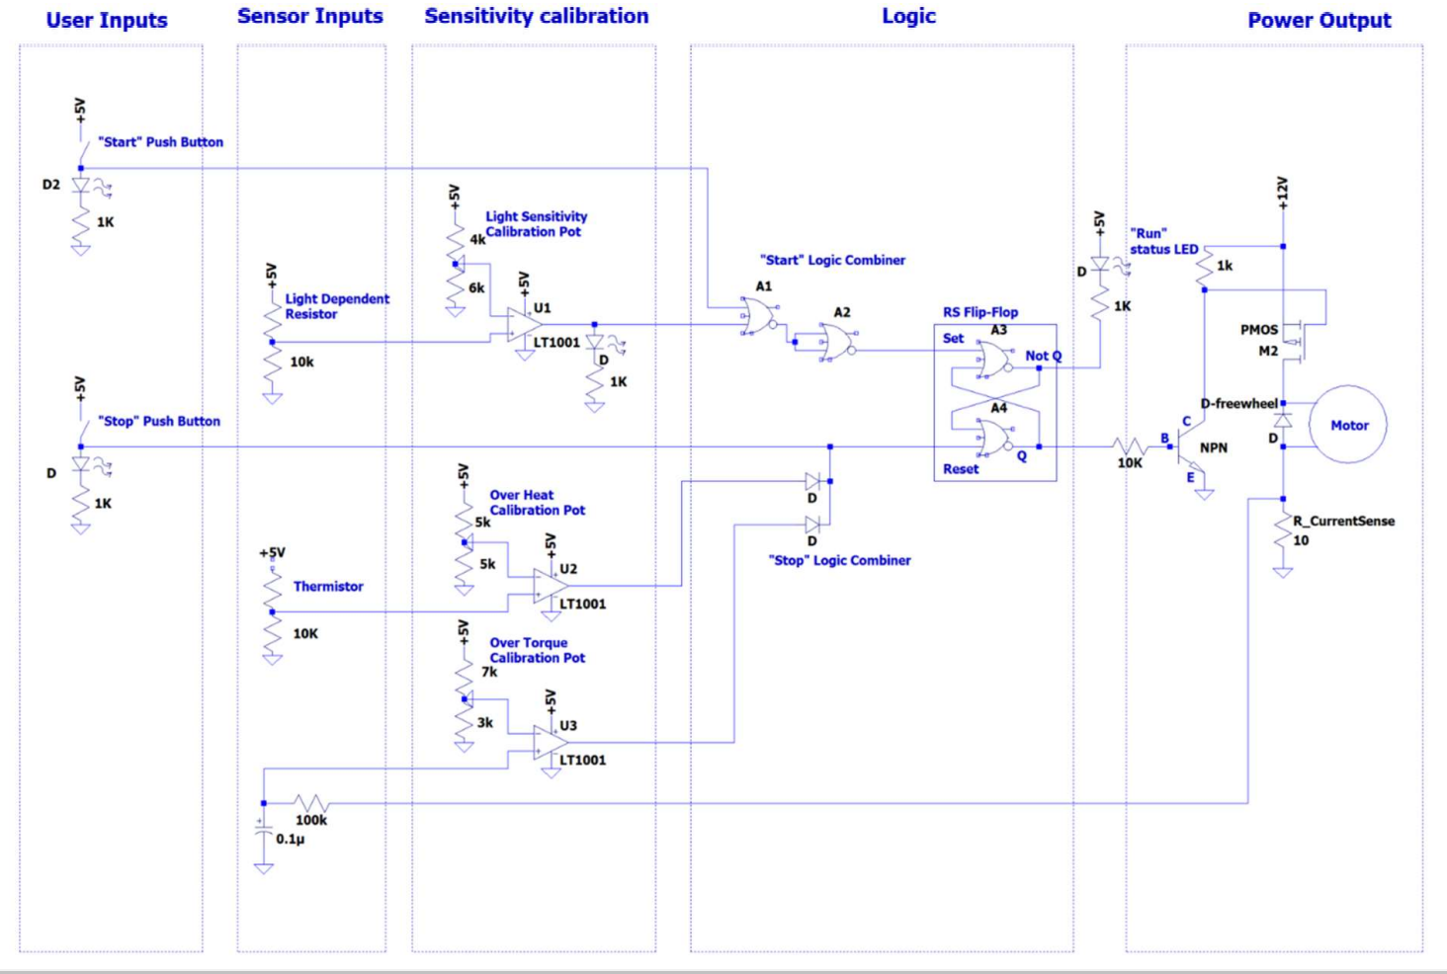
Figure 1 shows the circuit diagram as shown in the Lab Directions
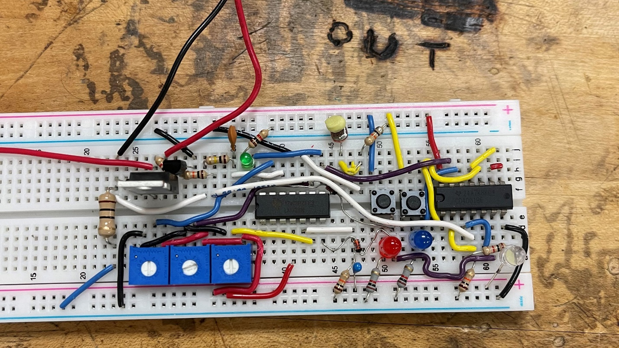
Figure 2 shows the built circuit. Note the odd substance covering the Light sensor is a piece of gum, due to the sensor being too sensitive.

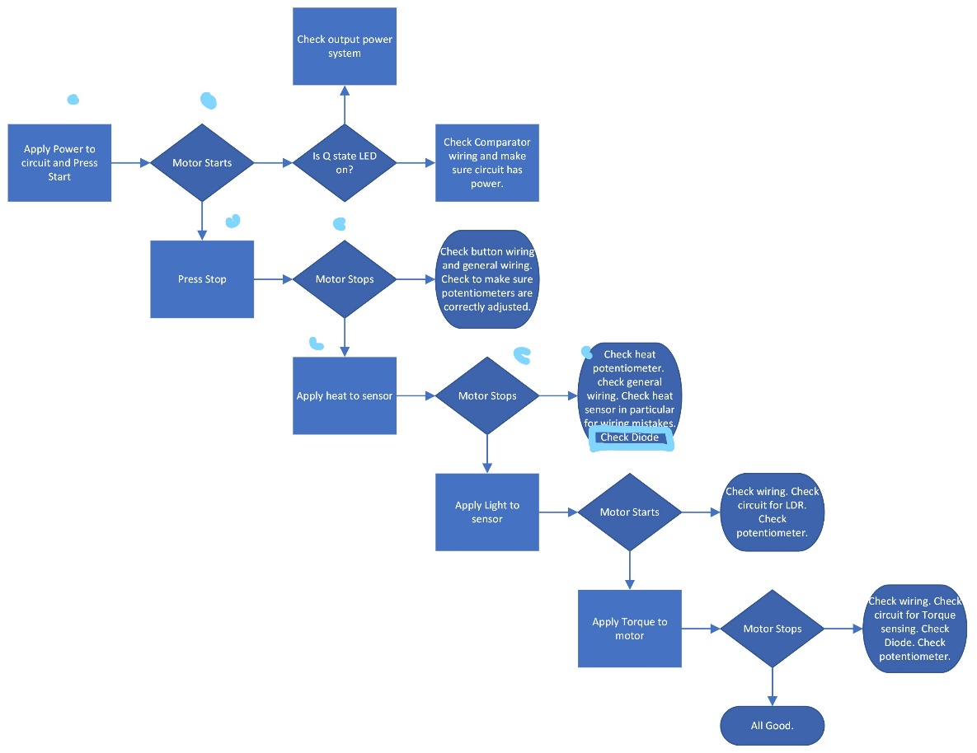
Figure 3 shows the steps taken to solve the first error introduced by the TA.
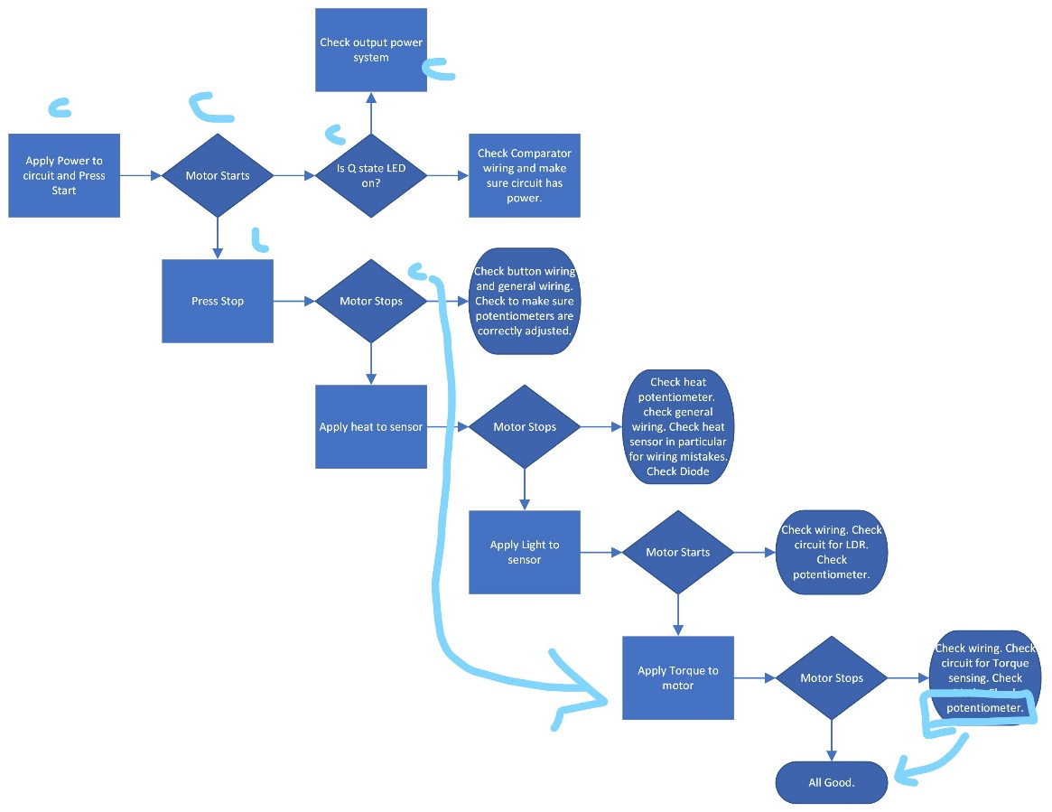
Figure 4 shows the steps taken to solve the 2 other errors the TA introduced.
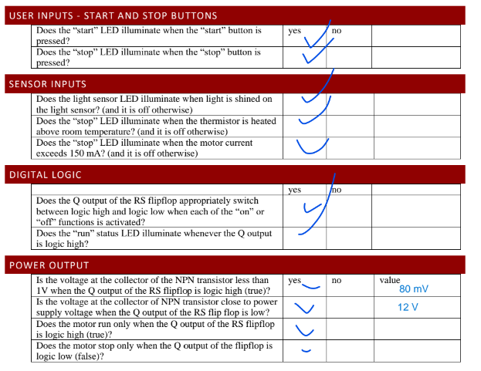
Figure 5 shows the checklist filled out to prove the circuit works.

Equations
$V_{out}=V_{in}\left(\frac{R_{lower}}{R_{lower}+R_{upper}}\right)$ (Eq 1)

References
[1] https://www.electronicsforu.com/technology-trends/learn-electronics/flip-flop-rs-jk-t-d

